Computing a Median and the Selection Problem
The selection problem is the problem of finding the kth smallest element in a list of n numbers. This number is called the kth order statistic. If k=1 or k=n, the problem is to find the smallest or largest element, respectively. If , the problem is to find an element that is greater than one half of the list’s elements and smaller than the other half. This middle value is called the median.
Example:
Finding the median of the following list of nine numbers: 4, 1, 10, 9, 7, 12, 8, 2, 15.
Solution:
Partitioning an array’s elements into two subsets: the one containing the elements that are less than or equal to some value ‘p’ pivoting the partition and the other containing the elements that are greater than or equal to ‘p’.
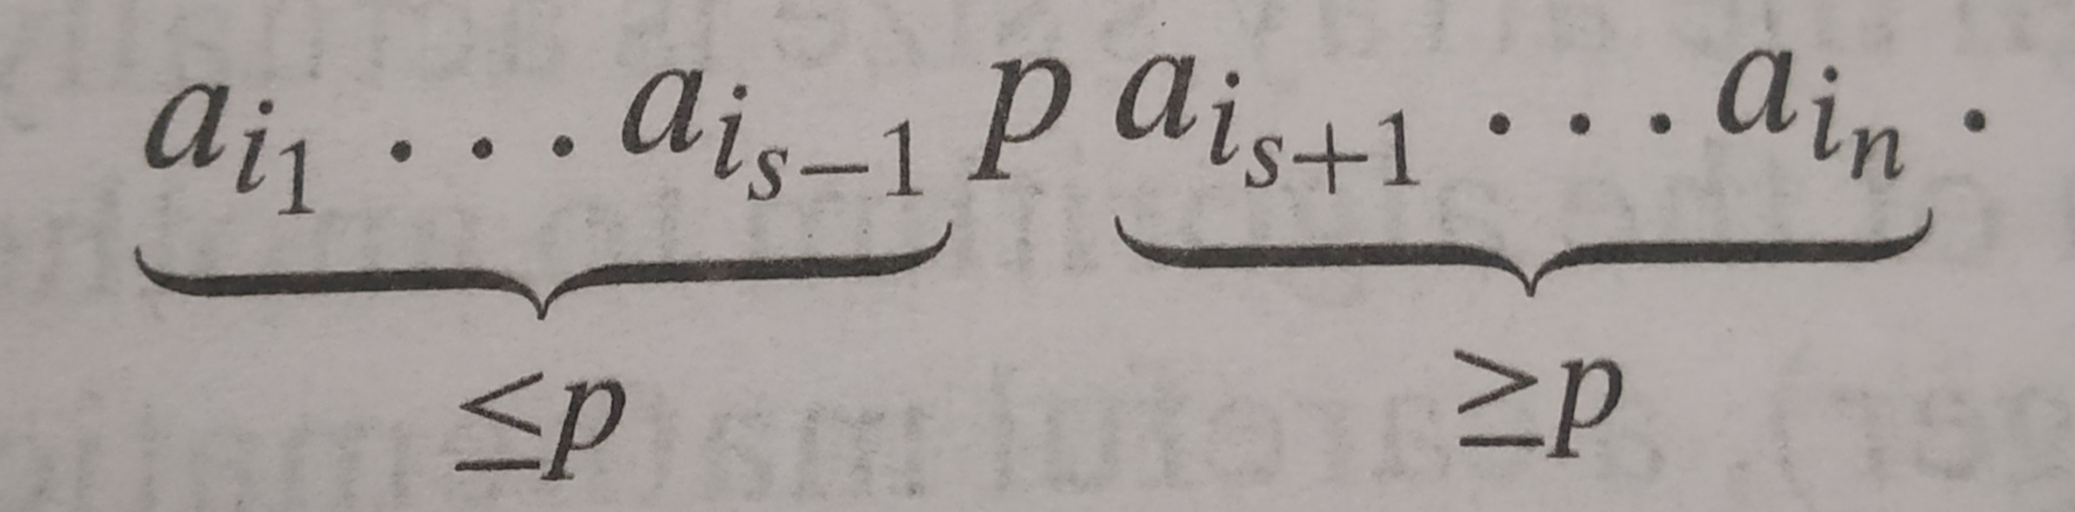
Let s be the partition’s split position. If s = k, the element in the pivot position is the value. If s > k, the kth smallest element is present in the left part of the partitioned array. If s < k, the (k – s)th smallest element is in its right part.
4, 1, 10, 9, 7, 12, 8, 2, 15
The number of elements in the list, n=9
Our task is to find the fifth smallest element in the list (ie., the element 8).
Assumption: For the sake of convenience, elements in the list are indexed from 1 to 9

Step 1:
First element ‘4’ is selected as pivot, ie p=4, after partitioning the elements in the list are
2 1 4 9 7 12 8 10 15
After partioning, the position of pivot is 3, ie., s=3,
Now we have to check whether s is less than, or equal to or greater than k. Here s is less than k. Now, the search proceeds with the element in the right part of the pivot.
Step 2:
9 7 12 8 10 15
Now element ‘9’ is selected as pivot, ie p=9, after partitioning the elements in the list are
8 7 9 12 10 15
After partioning, the position of pivot is 6, ie., s=6,
Now we have to check whether s is less than, or equal to or greater than k. Here s is greater than k. Now, the search proceeds with the element in the left part of the pivot.

Step 3:
8 7
Now element ‘8’ is selected as pivot, ie p=8, after partitioning the elements in the list are
7 8
After partioning, the position of pivot is 5, ie., s=5,
Now we have to check whether s is less than, or equal to or greater than k. Here s is equal to k. Now, the search ends and the median found is 8, which is greater than 2, 1, 4, and 7 but smaller than 9, 12, 10, 15 (ie, median is greater than one half of the list’s elements and smaller than the other half).
Time Complexity:
Basic Operation: Comparison
This algorithm is more efficient than the quicksort in the average case because it has to deal with just a single subarray after a partition while quicksort has to work on two half of the array.
Best Case Time Efficiency:
Partitioning an n-element array always requires n+ 1 key comparison. If it produces the split that solves the selection problem without requiring more iteration, then for this best case we obtain
C_{best}(n) = n+1= Ɵ(n).
Average Case Time Efficiency:
(n+1) comparison is required to identify one half of the array and if the split always happen in the middle of the selected subarray, the recurrence for the number of comparison is,
C_{avg}(n) = C(n/2) + (n+1)
According to master theorem,
a=1, b=2, f(n)=n, (therefore d=1)
here, a is less than b^{d} (ie., 1<2¹)
Therefore, C_{avg}(n) = Ɵ(n^{d})
= Ɵ(n¹)
= Ɵ(n)

Worst Case Time Efficiency:
Unfortunately, the algorithm can produce an extremely unbalanced partition of a given array, with one part being empty and the other containing n−1 elements. For a speciﬁc example of the worst-case input, consider, say, the case of k=n and a strictly increasing array. This implies that,
C_{worst}(n) = (n+1)+(n)+...+3
=
= Ɵ(n²)

